Credit

2140

Assignment

E6 **MathTutor**

Errors

What caused the error and how do you overcome the error?

Wrong value for the if statement 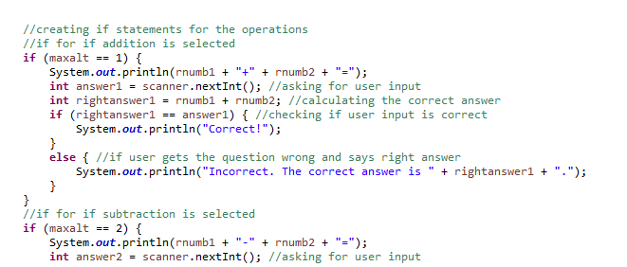

Should be rnumb3 not maxalt, easy fix just needs to be replaced

Only eor